INTERNATIONAL UNIVERSITY OF SARAJEVO

**Bus Seat Booking System**

Software Design Specification

04/05/2016

Group 1:

-Ibrahim Guler 1010319

-Ozgur Altınkaya 1010357

-Yousef aly 130303008

-Emad Obaidat 992441

-Abdullah Alrez 992450

Version 1.0

**1.Introduction**

**Overview**

The Proposed system for this Bus Reservation system, will allow users to plan a trip, reserve seat, select departure date and departure location, set arrival location. The proposed system will be designed using QT because it supports great and simple deal of human computer interaction.

## 1.1 Purpose

The purpose of this document is to provide the Specification-Design Document for the Bus Reservation System software. This document is intended for software engineers.

## 1.2 Scope

This document describes the high level and detailed design of the Bus Reservation System including the functional decomposition specification of the functional components, System Decomposition Design (class diagram), Uses cases, Sequence Diagrams and User Interface Design.

## 1.3 Definitions

### 1.3.1 Functional Decomposition

Functional decomposition refers broadly to the process of resolving a [functional](http://en.wikipedia.org/wiki/Function_(mathematics)) relationship into its constituent parts in such a way that the original function can be reconstructed (i.e., recomposed) from those parts by [function composition](http://en.wikipedia.org/wiki/Function_composition) [1]. Here, the functions are in the process of taking a complex process and breaking it down into its smaller, simpler parts.

### 1.3.2 Class Diagram

A class diagram is an illustration of the relationships and source code dependencies among classes in the Unified Modeling Language (UML). In this context, a class defines the methods and variables in an object, which is a specific entity in a program or the unit of code representing that entity [2]. The all classes that exists in the system and their relations between each of them is shown by diagram

### 1.3.3 Uses Case Diagram

A use case describes a sequence of actions that provide something of measurable value to an actor and is drawn as a horizontal ellipse [3]. The purpose of using use case diagram is to see the functions which are used in the software. In this section,how type of users uses the functions in the software will be shown

### 

### 1.3.4 Sequence Diagram

The Sequence Diagram models the collaboration of objects based on a time sequence. It shows how the objects interact with others in a particular scenario of a use case [4]. All the functions, requests and replies into the system which are example (click the register button what would happen) are shown how it goes on.

### 1.3.5 User interface (which language is used to build GUI)

In this section, the user interface of the software which are login menu,registration form will be shown

**3. Functional Decomposition**

## 3.1.Destination

|  |  |  |  |
| --- | --- | --- | --- |
| **Name** | **Input(s)** | **Description(s)** | **Output(s)** |
| **Destination** | Enter Location from and location to | It is chosen to location from and to | System will automatically save locations. |
| **Date** | Enter departure and returning dates | It is confirm date for trip | System will automatically save dates and writes to reservation. |
| **Passenger** | Search Bus, enter date and bus details | Check for available bus and date | System will automatically save number of people and type to reservation. |

## 3.2. Transportation

|  |  |  |  |
| --- | --- | --- | --- |
| **Name** | **Input(s)** | **Description(s)** | **Output(s)** |
| **Type** | Choose bus type | We have some brands of bus which have some comfortable essentials and you can choose what you want | System will automatically save which type of buses |
| **Additional Option** | Choose seat which have options | After choosing seat you will see differences | System will save seating type |

## 3.3 Payment Method

|  |  |  |  |
| --- | --- | --- | --- |
| **Name** | **Input(s)** | **Description(s)** | **Output(s)** |
| **Payment Method** | Select a payment method | We have three option to pay vacation. They are cash credit card and bank transaction. | If we choose cash, automatically other two function will be unactivate and will save. If we choose credit or transaction, process will continue |
| **Card Details** | Enter card information | We have to enter card information for transactions. | System will save the details but will not show on the vacation report. |
| **Number of Transactions** | Select transaction months | We can choose transaction period in this part for credit card. | System will save with credit card information. |

## 3.4. Options

|  |  |  |  |
| --- | --- | --- | --- |
| **Name** | **Input(s)** | **Description(s)** | **Output(s)** |
| **Customer** | Choose a customer | Admin can choose a customer information and can make some changing on the customers vacation | The customer information and vacation details will be open by the system. |
| **Reservation** | Choose a reservation | We can check reservation and make some changing on the reservation. | Reservation will be open that we select. |
| **Log Out** | Push to switch off | İt is for switching off the program | System will switch off itself. |

**User**

• This Project basically provides a Bus information and regarding bus information .

• First of all, in our system any user or visitor are view our system and also search the bus and how many seats are available in our buses.

• User can also registered its own seats in bus this system . User can post a comment on different Bus Services. But user can compulsory registered first in the system.

• Search Bus category wise .

**Admin**

•In this system admin can maintain all the Bus information and also maintain Bus category , comments etc.

• In this system admin can maintain the registered users , manage news ,and also admin can generates a reports and manage the whole system .

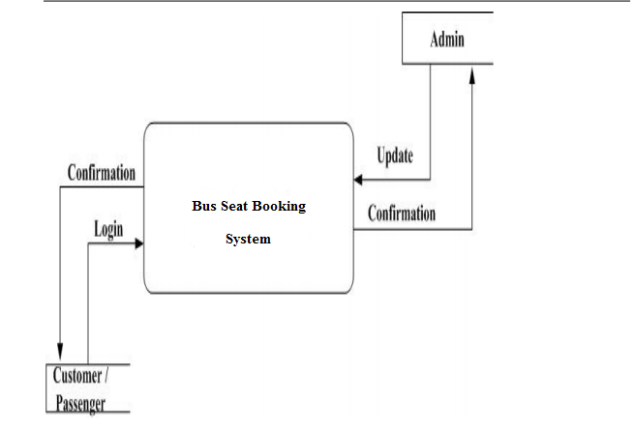

**Login**: Login includes various utilities like User Authentication, Change Password and Forgot Password.

**Registration**: In this system provide a some facility user can Registered in this system. user can use this facility so user can make a registration.

**Book the Ticket**: In this part admin can add new bus category using this module. Bus Category contains like Volvo, Slipper coach, Ac Coach etc.

**Update Bus Information**: In this part admin can add or Update Bus using this module. It contains the information about the Bus type , photo, description, Location of tour, Available Seats in Bus etc.

**Cancel the Booking Ticket**: In this Module User can Cancel the booking Ticket.

**Comments**: In this Module User can Post the Comment on a particular Bus .

**Report Generation**: This module is used to generate a reports.

**4. System Decomposition/Design**

**YOUSELF ADD YOUR PART**

**Use Case Diagram**

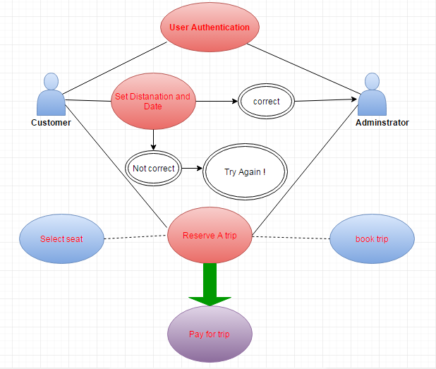

|  |  |
| --- | --- |
| **This use case the shows how a customer of an Bus Seat Booking system can reserve trip online.** | |
| **Actors:** | Customer, Adminstrator |
| **Precondition:** | The customer must reserve a trip before payment, the customers and the adminstrators must make sure that details are correct. |
| **Basic flow of event:** | * Usres Log into the system * Users enter trip details * Users enter their personal details such as name and address * Users reserve ticket |
| **Alternate Flow:** | * If the user enters wrong information like if the departure date is after the supposed arrival date, a pop message would show up * If no destination id added to the system would tell the user to add a destination |
| **Key Scenarios:** | The user must enter the correct details before sending the request. |
| **Post Condition:** | * Successful completion: the user has finished making the Reservation and has recived the ticket * Failure completion: the user did not enter the details correctly, or did not pay. |
| **Special Requirement:** | * The user must be connected to the internet * User should use webs browsers such as Google Chrome. |

**Scenerio**

|  |
| --- |
| 1. The user is provided with a form to fill in order to provide the adminstrator with their details(name,address) and about their details of the trip. |
| 1. The user submits the information to the service in order to get a list of trips according to their scheduale. |
| 1. The adminstrator finds a list of the trips. |
| 1. The user choose which trip is the best for their schedule. |
| 1. The user pays for the reservation. |
| 1. The adminstrator checks all the information of are right and then send to the customr reciept the they have succssefuly reserved a ticket for the trip. |

**What can go wrong?**

**i)** Paymentinformation can be entered wrongly, therefore it can make a problem during payment .

**ii)** User can choose a route that doesnt exist so fails to reservate

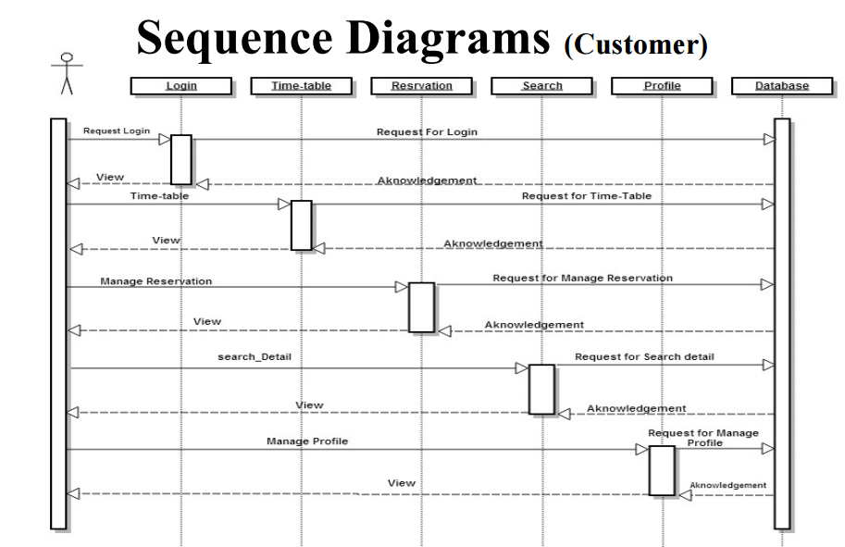

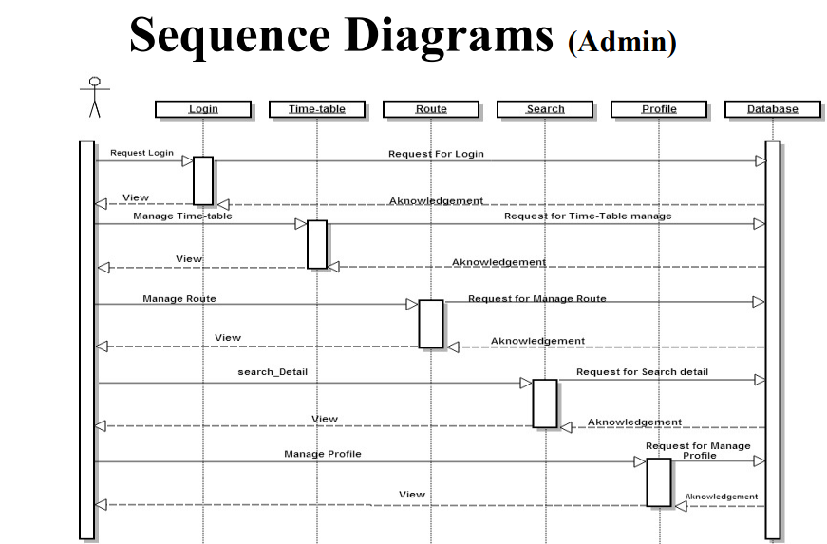

**6.USER INTERFACE**

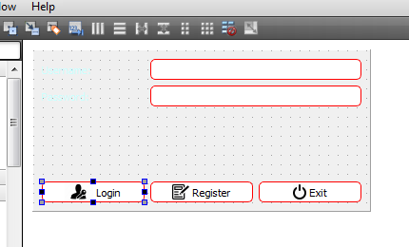

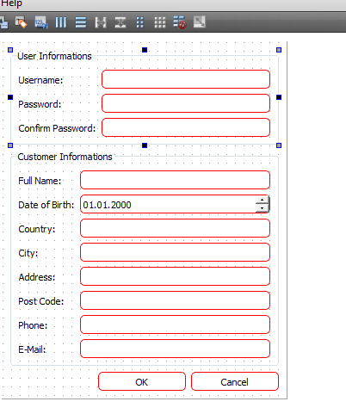

**REFERENCES**

[1] http://en.wikipedia.org/wiki/Functional_decomposition

[2] searchsoa.techtarget.com/definition/class-diagram

[3]http://www.agilemodeling.com/artifacts/useCaseDiagram.htm#sthash.FskFKcFD.dpuf

[4]http://www.visual-paradigm.com/VPGallery/diagrams/Sequence.html[5] [5]http://gnu.inflibnet.ac.in:8080/jspui/bitstream/123456789/2212/1/ONLINE%20BUS%20BOOKING%20SYSTEM.pdf

[6]Development of an Online Bus Ticket Reservation System for a Transportation Service in Nigeria PDF BOOK